System Component Design and Activity Diagrams
This section presents a detailed low-level design of each major component of the Smart Diaper–based UTI Detection System. For each component, a functional description, activity flow, and the technologies or methods used are elaborated. The corresponding activity diagram visually explains the internal logic and data flow of each unit in the system architecture.

1.Smart Diaper Sensors:

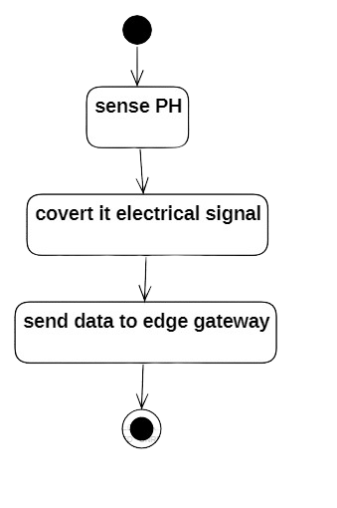
The smart diaper sensor unit is responsible for detecting changes in the pH level of the urine. This pH sensor continuously monitors the moisture and chemical composition to determine if the conditions are indicative of a potential urinary tract infection (UTI). Once the sensor detects the pH value, it converts the chemical signal into an electrical signal using an onboard analog-to-digital converter or microcontroller. This electrical data is then packaged and transmitted wirelessly to the edge gateway via BLE (Bluetooth Low Energy) or another short-range protocol. The diagram above illustrates the basic flow: sensing the pH, converting it to an electrical signal, and transmitting the data for further analysis.

2.Edge Gateway (BLE/WiFi Microcontroller)
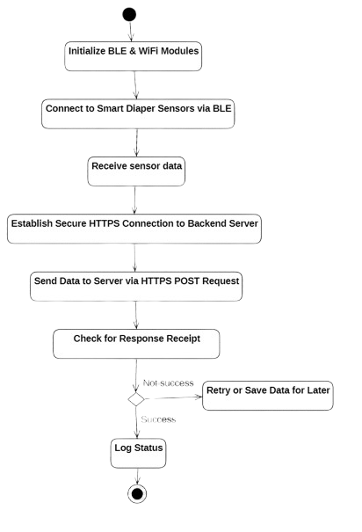

The Edge Gateway plays a critical role in bridging the smart diaper sensors and the cloud backend. Initially, it activates its BLE and WiFi modules, preparing for communication. It then connects to the smart diaper sensors via BLE and receives sensor data, such as pH level readings. Upon receiving the data, the gateway establishes a secure HTTPS connection with the backend server. It transmits the collected data using an HTTPS POST request, ensuring secure and reliable communication. After transmission, the gateway checks for a server response to confirm successful delivery. If the transmission is unsuccessful, it retries the operation or stores the data locally for future attempts. Upon a successful response, it logs the transmission status for record-keeping and debugging. This intelligent gateway design ensures resilience, secure transmission, and seamless integration between sensor data collection and cloud analytics.

3.Cloud Base:
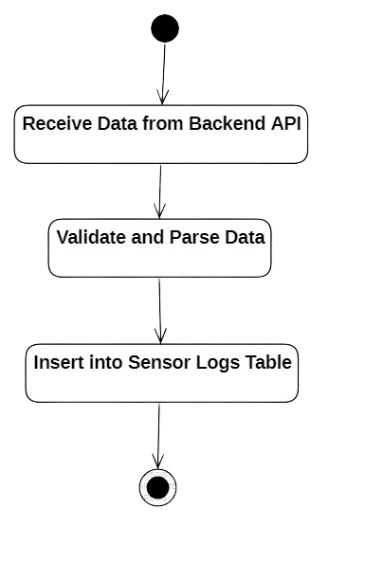
The Cloud Database acts as the central repository for all incoming sensor data transmitted from edge devices. Once the backend API receives the data, it undergoes a validation and parsing process to ensure the data is correctly structured and free from anomalies. After successful validation, the data is inserted into a cloud-hosted Sensor Logs Table, enabling high availability, scalability, and remote access. This cloud-based setup ensures that the system can handle large volumes of real-time data efficiently while providing support for advanced querying, analytics, and integration with other cloud services such as ML models, alert systems, and dashboards. It forms the backbone of historical tracking, health monitoring, and automated detection mechanisms.

4.UTI Analyzer:
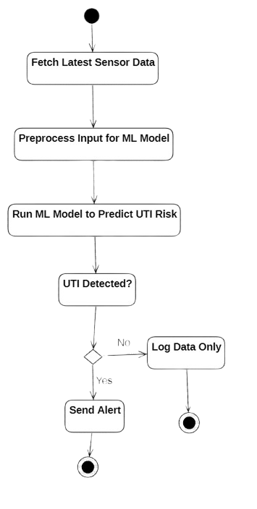
The UTI Analyzer component is responsible for predicting potential urinary tract infections using machine learning. It fetches the latest sensor data stored in the cloud and performs preprocessing to format and normalize the data for the ML model. The processed data is then fed into a trained model, which outputs the UTI risk level based on physiological and environmental patterns. If the model detects a high risk, the system immediately triggers an alert to caregivers or healthcare providers. If no risk is detected, the system simply logs the data for future reference. This intelligent and automated detection approach improves early diagnosis, reduces manual monitoring, and supports proactive healthcare intervention.

5.Backend Server:
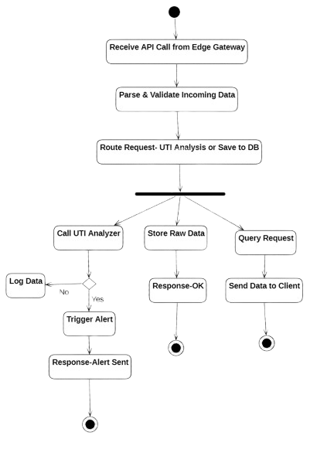

The Backend API Flow manages the core data operations and orchestrates communication between system components. It receives incoming API calls from the edge gateway, which typically originate from IoT sensors in the smart diaper. The incoming data is first parsed and validated to ensure correctness and integrity. Based on the content and type of request, the backend then routes the request to one of three operations:
- UTI Analysis via the UTI Analyzer,
- Raw Data Storage in the cloud database, or
- Client Query Handling for reporting or dashboard visualization.
If the request involves UTI risk detection, the backend calls the UTI Analyzer, and based on the analysis result, it either logs the data or triggers an alert to notify caregivers. All operations return appropriate responses such as Alert Sent or OK to confirm successful execution. This design ensures scalability, modularity, and real-time responsiveness of the system.

6.Notification Service (SMS/Email Gateway):
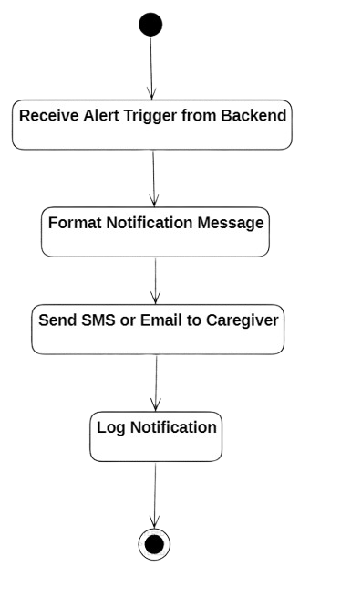
The Notification Service is responsible for real-time alert delivery to caregivers in case of UTI risk detection. It is triggered by the backend once an alert condition is met. Upon receiving the trigger:
- The system formats a notification message with relevant patient information, risk level, and timestamp.
- The message is then delivered via SMS or email using integrated third-party services (e.g., Twilio for SMS, SMTP or SendGrid for email).
- After dispatching, the service logs the notification for auditing and compliance purposes.
This lightweight service ensures immediate communication and traceability, improving caregiver responsiveness and patient safety.

7.Caregiver App:
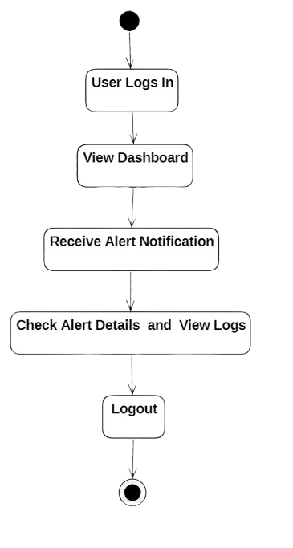

The Caregiver App (Mobile/Web UI Layer) serves as the primary interface for caregivers to monitor real-time alerts and historical health data related to patients, particularly in the context of UTI detection. Upon launching the app, caregivers securely log in using their credentials, after which they are presented with a dashboard displaying current patient status. When a UTI or abnormal condition is detected, an alert notification is received within the app. Caregivers can then view detailed alert information or browse through historical logs to assess the patient's condition over time. After reviewing, they can securely log out, ending the session.

